DBMS Technical Task
Dhanalakshmi K
E25AI110
BSc. Computer Science
With
Artificial Intelligence

WEEK 5 :PAYMENT TRANSACTION MANAGEMENT SYSTEM
The Payment Transaction Management System is designed to manage and maintain payment information for customer orders in an e-commerce system. It records payment details, tracks transaction status, manages successful and failed payments, and generates useful payment-related reports.

1.Create Payment Table:
The Payment_ID uniquely identifies each payment transaction. The Order_ID connects the payment with its corresponding order. The Payment_Date stores the date on which the transaction was made, while the Payment_Mode stores the method used for making the payment. The Payment_Status indicates whether the payment was successful, failed, or pending. The Transaction_Amount stores the amount paid by the customer. The primary key ensures that every payment has a unique identifier, while the foreign key connects the Payment table with the existing Orders table.
Attribute | Description
Payment_ID | Unique payment identifier
Order_ID | Order reference
Payment_Date | Date of transaction
Payment_Mode | UPI/Card/Net Banking/Cash
Payment_Status | Success/Failed/Pendi ng
Transaction_Amount | Paid amount

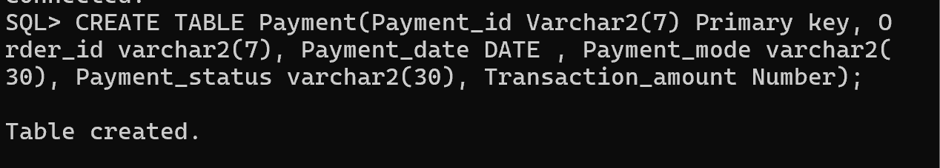

View the Structure of Payment Table:
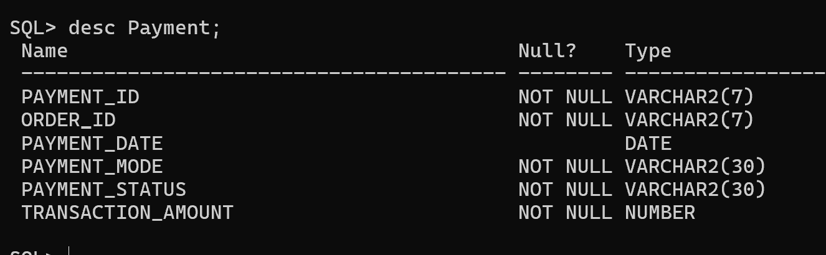
2.Insert Payment Details
The INSERT INTO command adds payment records to the Payment table. Each record contains a payment ID, order ID, payment date, payment mode, payment status, and transaction amount.
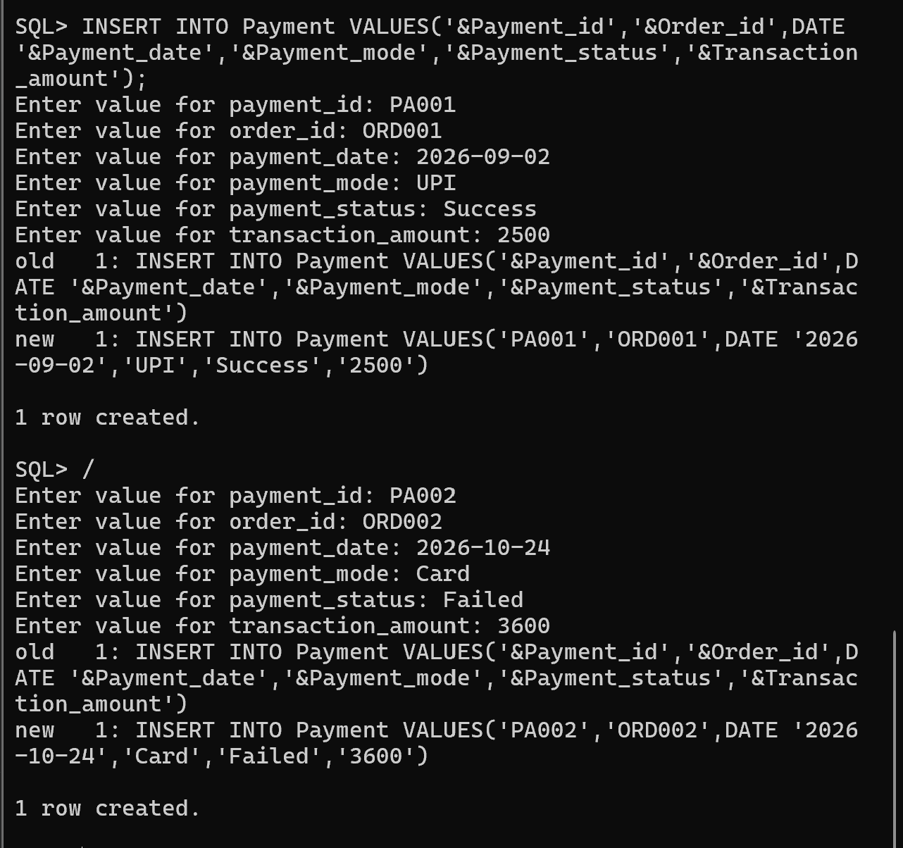

Display All Payment Details
The query displays all payment transactions stored in the Payment table.
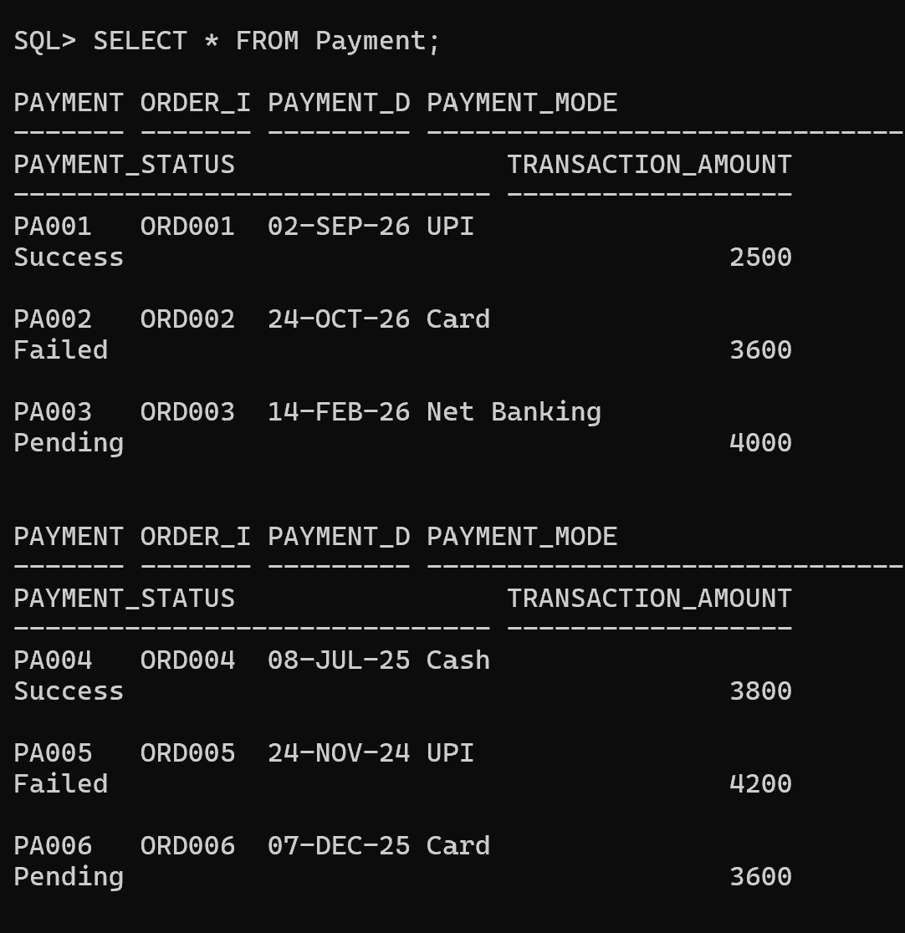

3.Manage Successful and Failed Transactions
- Display all successful payments - Only successfully completed payment transactions will be displayed.
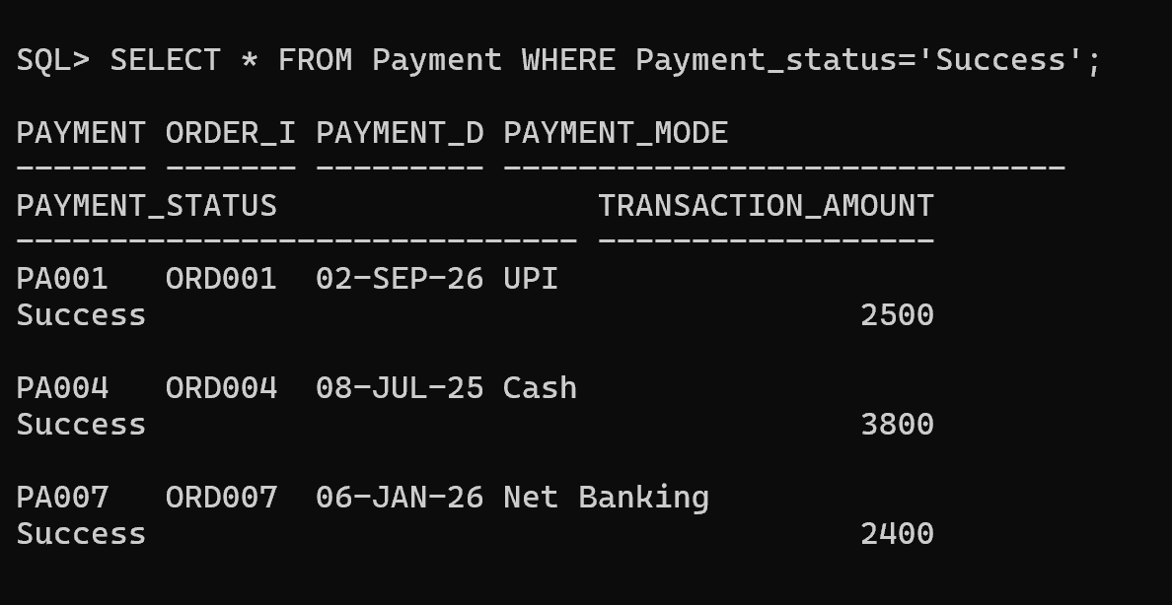
- Find failed transactions - All failed payment transactions will be displayed.
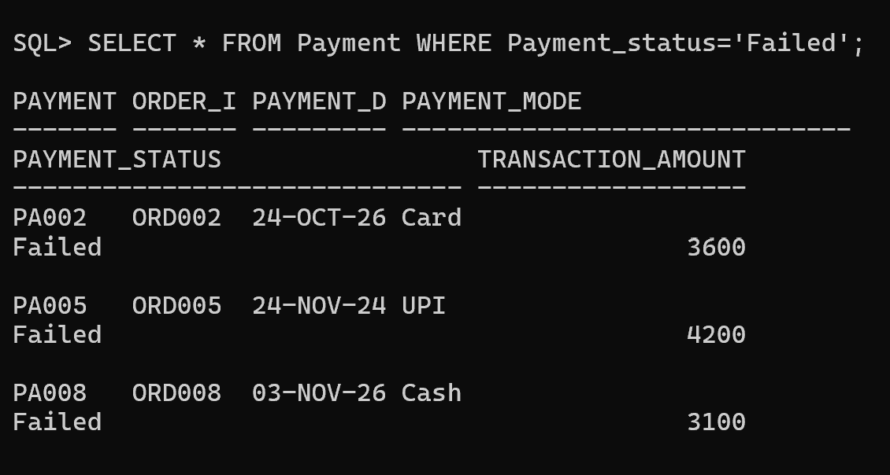
- Count total successful and failed payments - The result will show the number of successful and failed transactions separately.
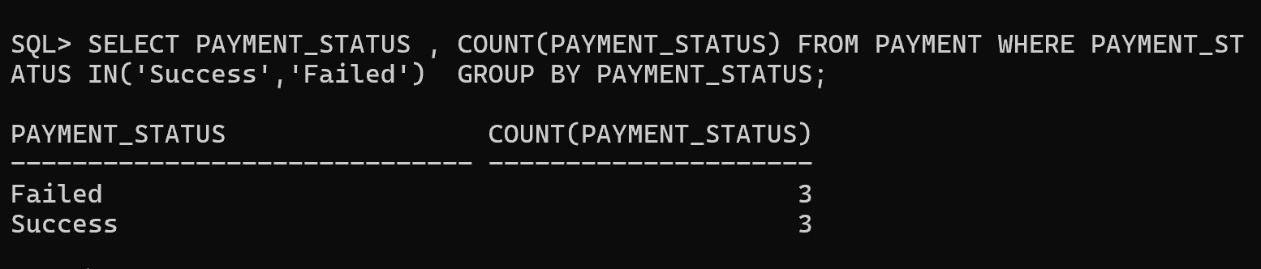

4. Analyze Payment Methods Used by Customers
- Payment Mode Analysis
- Number of transactions using UPI.
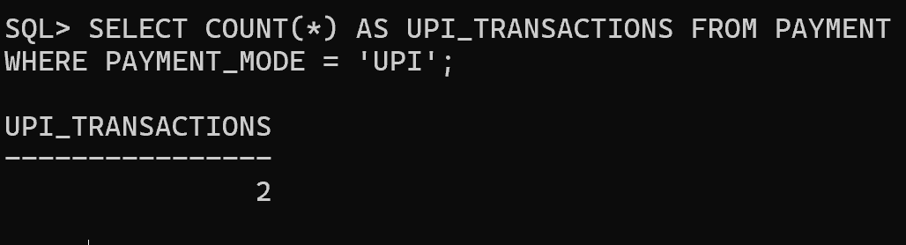
- Number of card payments.
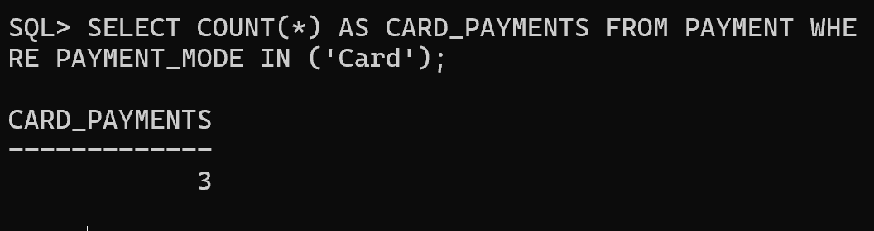
- Most preferred payment method.
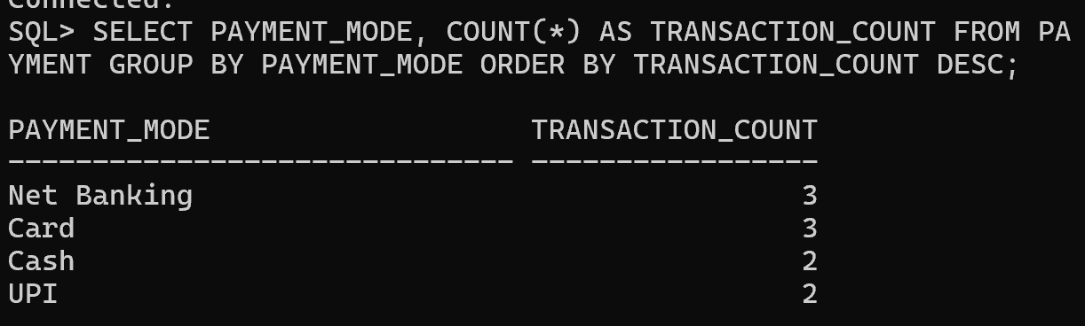
- Revenue Analysis
- Total revenue generated.
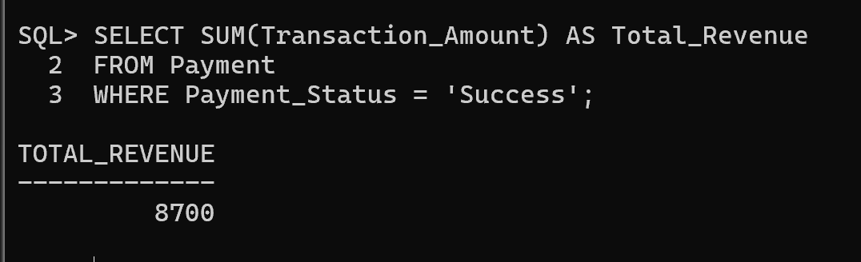

- Revenue by payment method.
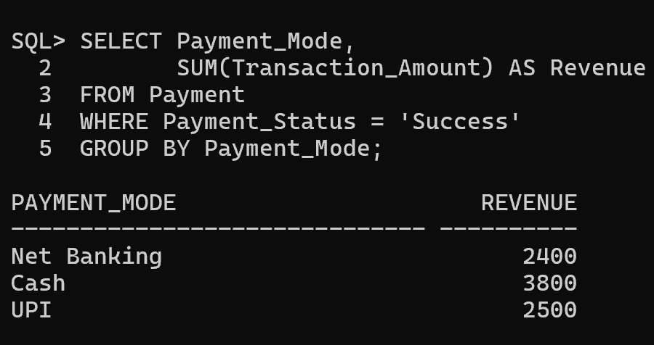
- Average transaction amount.
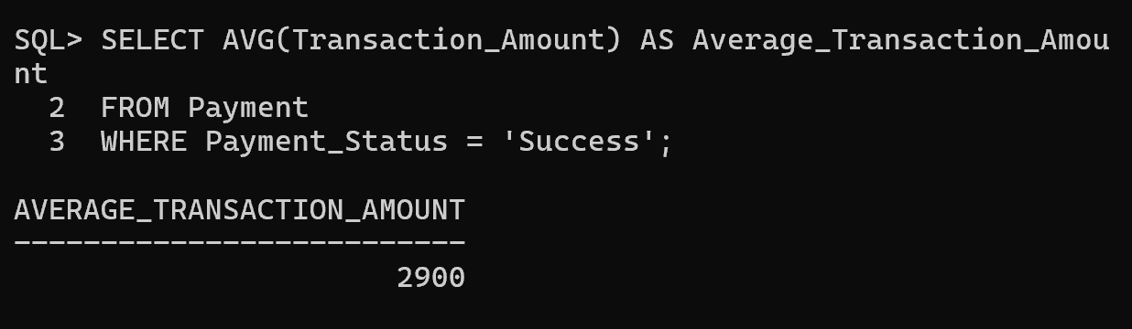
Customer Payment History
Display:
- Customer name
- Order ID
- Payment mode
- Amount
- Payment status
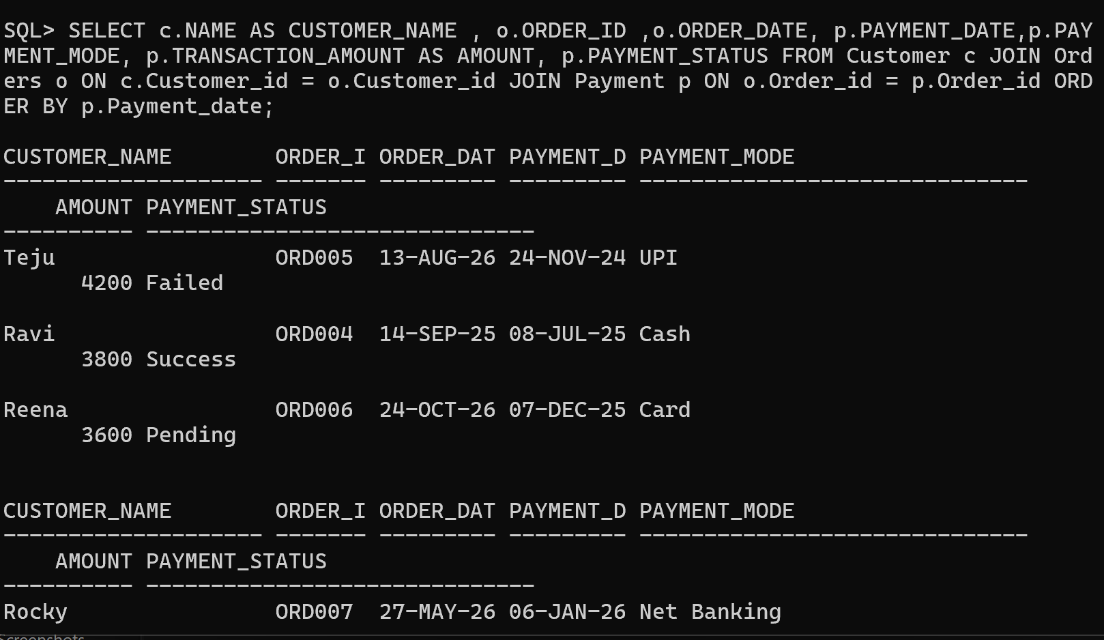

Payment Analysis:
